2023/05/31

CONTAINER ORCHASTRATION TOOL : WHICH WILL MANAGE CONTAINERS FOR YOU

**What is orchestration?**

Kubernate by it self is just doing the container orchestration / container management

But the actually work Docker is still being done by docker

Kubernate is only manage those container for you

**What is kubernate doing?**

Kubernate is doing container management / container orchestration

And actual work is still doing by container

Kubernate and Docker work together to build and run containerized application

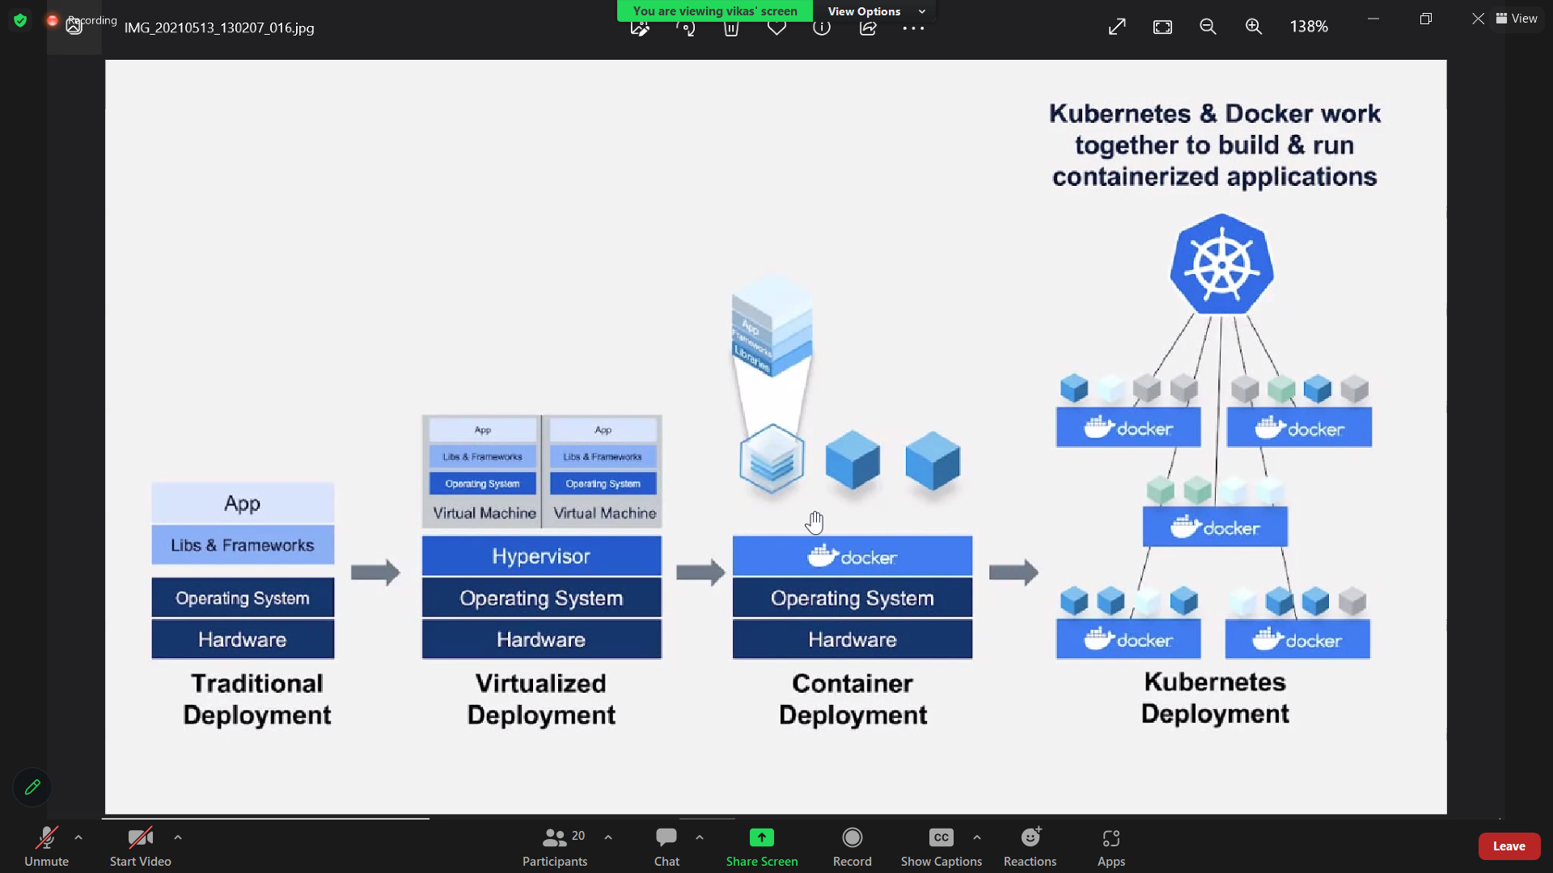

**HISTORY OF KUBERNATE:**

2014 INTRODUCED KUBERNATE

2018 WHICH IS POPULARER THIS KUBERNATE

THERE IS GAME POKEMON GAME

GOOLE IMPLEMENTED KUBERNATE

GOOGLE USE BORG TO RUN THEIR CONTAINER

K8S IS OPEN SORUCE

**KUBERNATE:**

KUBERNATE IS DESIGNED BY GOOGLE

OPEN SORUCE CONTAINER ORCHESTRATION

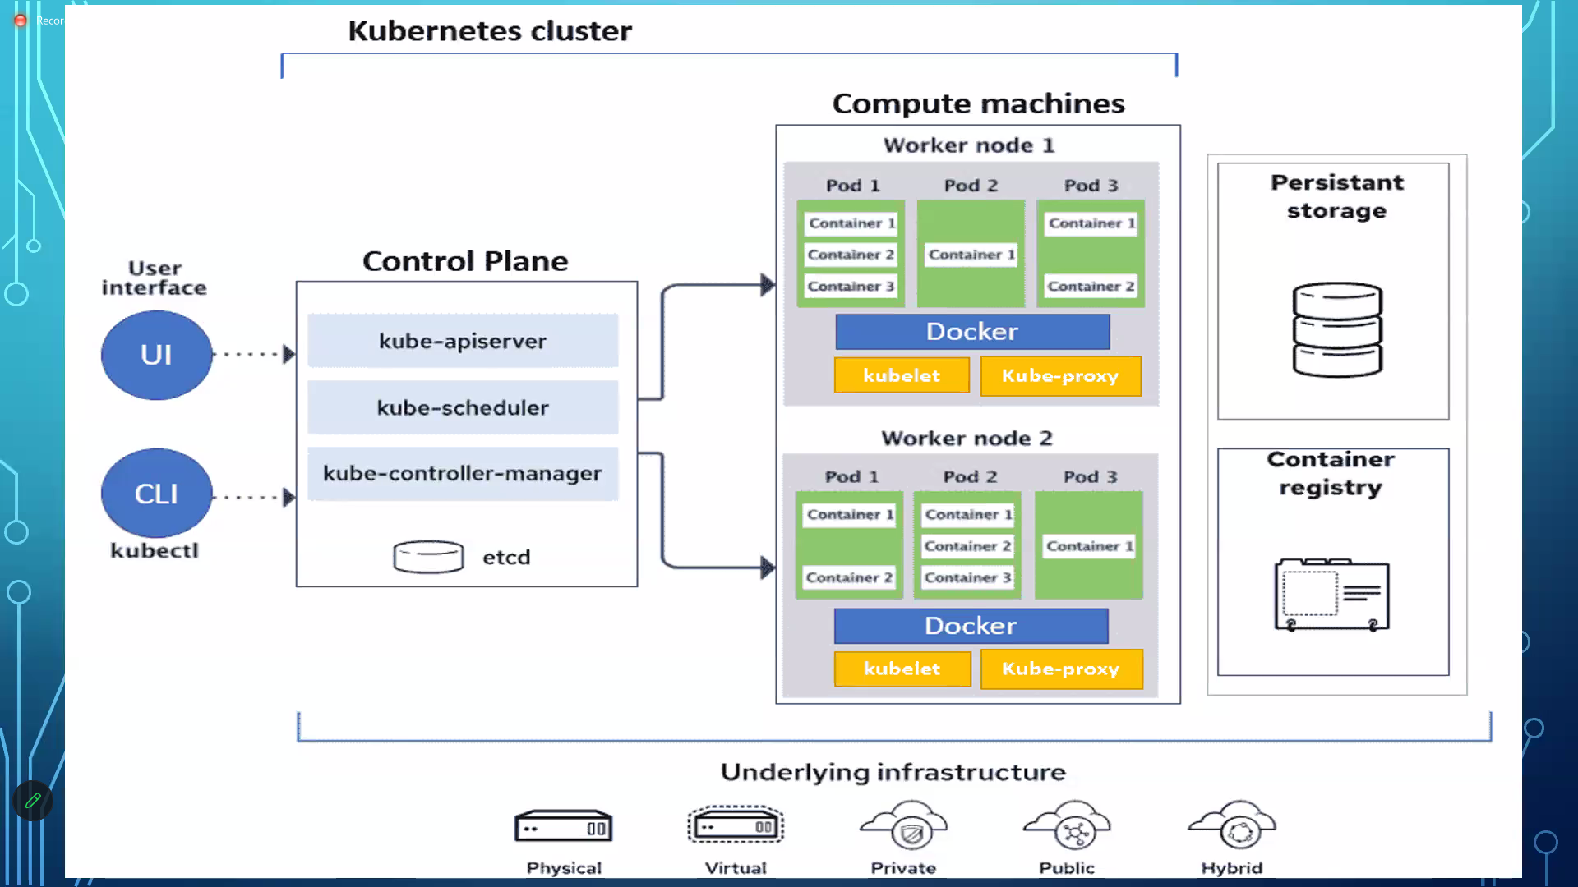

**K8S CLUSTER MEANS:** COMBINATION OF MASTER NODE AND WORKER NODE

N NUMBER OF MASTER NODE AND N NUMBER OF WORKER NDOE (NODE MEANS MACHINE)

KUBERNATE THEY CALLED AS k8S

**Q) tell me the size of cluster with which you have worked**

I have worked with 2 master nodes and 5 to 9 worker nodes

why 2 master nodes:

1 master node failed, I can switch to master 2

When every work load is increase we get more container, we run 10 worker nodes

When every work load is less, you run 2 worker nodes



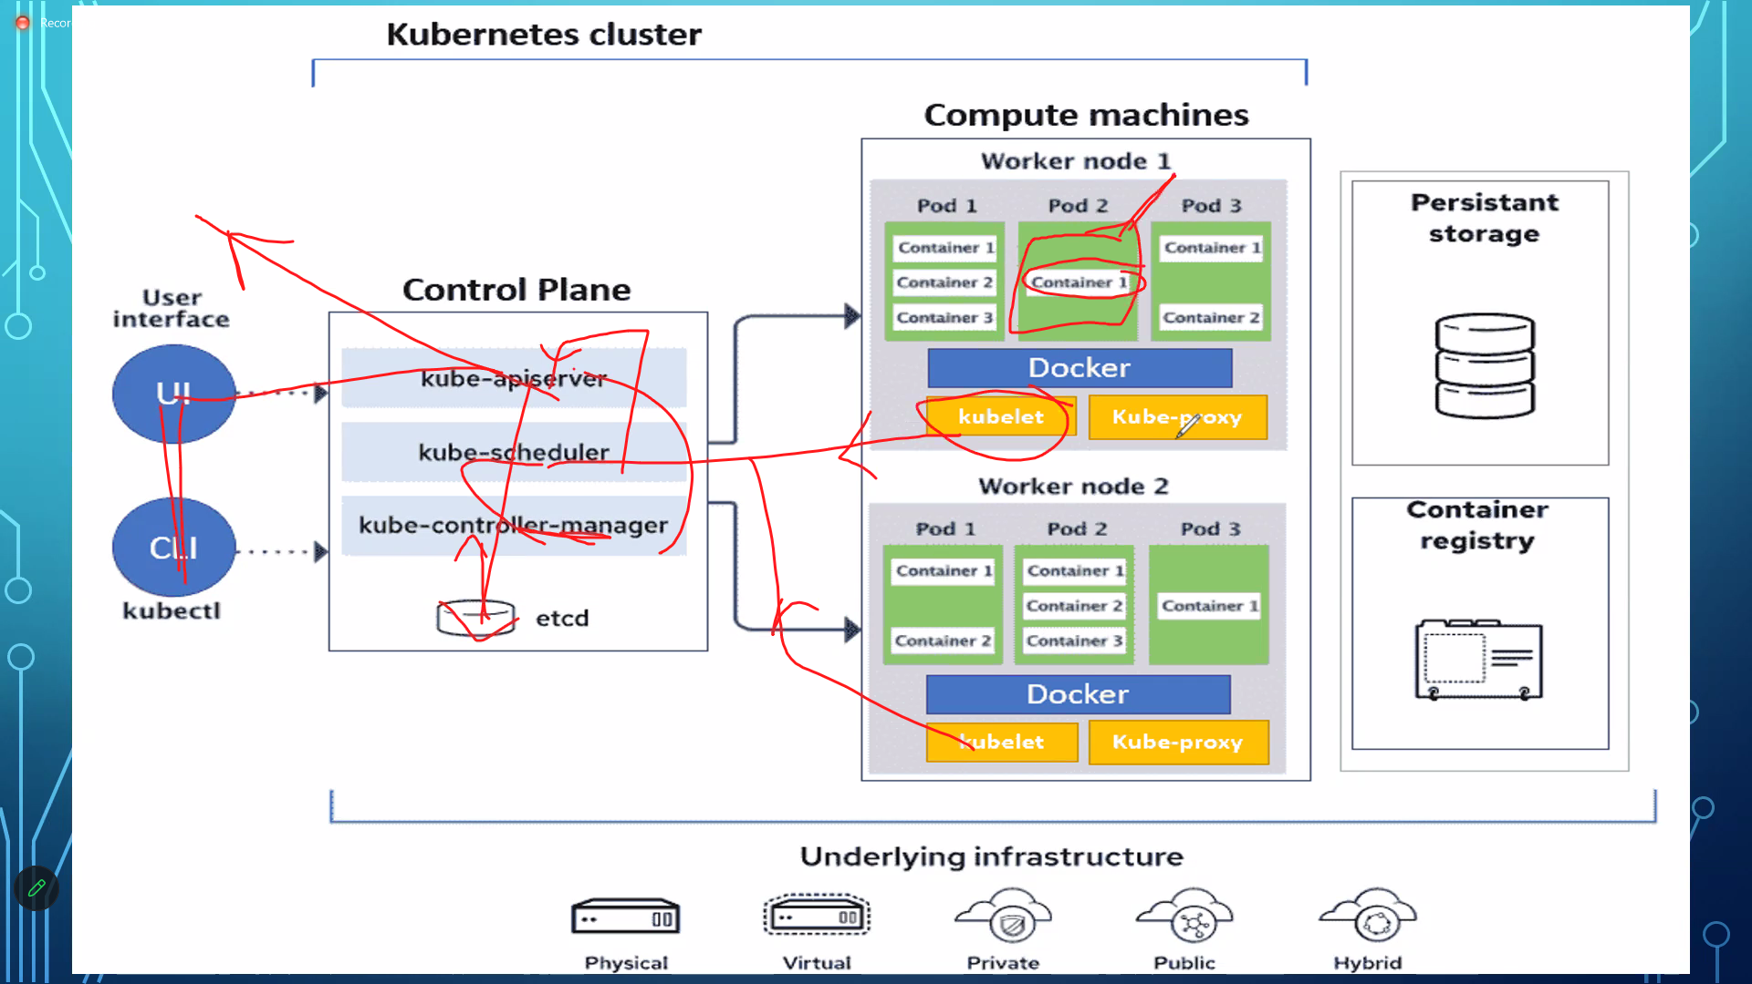

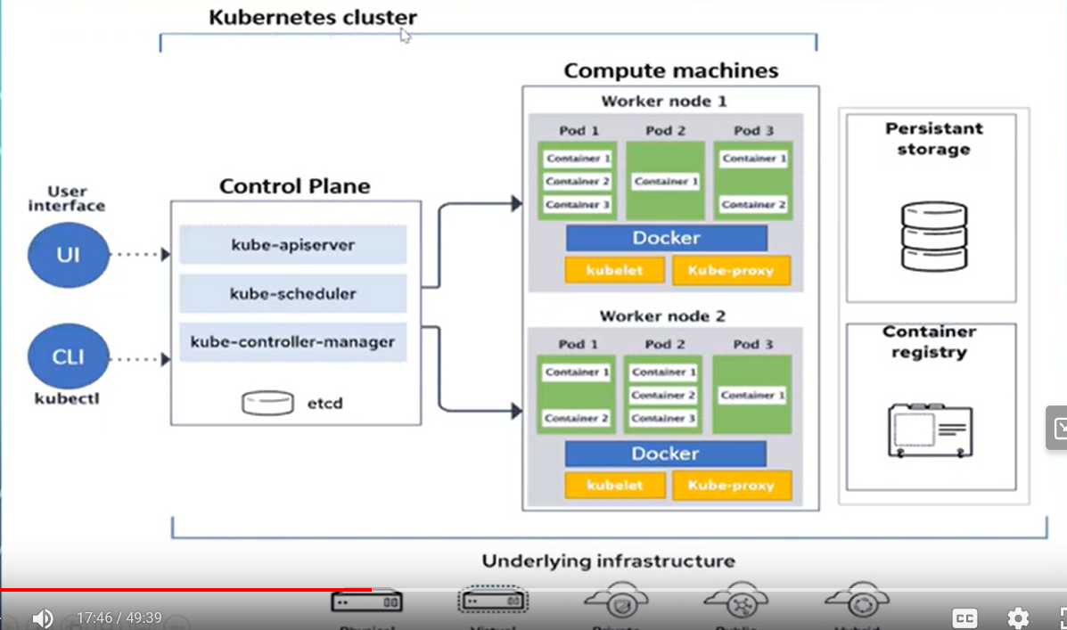

**Control Plane: Master Node**

Control plane has 4 components

**Cube-api-server:** act as a gateway or entry pointto your cluster, any request which is coming from outside world UI (user interface) or coming from kubectl (kubectl – kubernate controller )

The moment it will come, it will hit api-server

What it will do api-server?

To check the request authencity and authorization

He is valid person to make the request

If person or machine is valid one what every request they are making is that correct

If authencity and authorization is accepted then going to 2nd components

The kube-api server peridicolly fetches status reports from the kubelet to monitor status of nodes and containes on them

**Kube-control- manager:**

What every request is coming from outside world, it is desired state , it will take the desire state from cube api server

It will take the current state from etcd and it will compare it

**Etcd**: brain of the cluster**,** etcd basically database which store everything with key and value format

It will tell you what is the current state of cluster which means how many worker nodes are running and how many containers are running

If worker node is running it is fully occupied or it is not occupied

Those kind of details , it has all details what every happen inside container

**SCHEDULER**: As soon as it will find the diff from control manager, control manager go and inform to scheduler

Then take this task and finish it on worker node

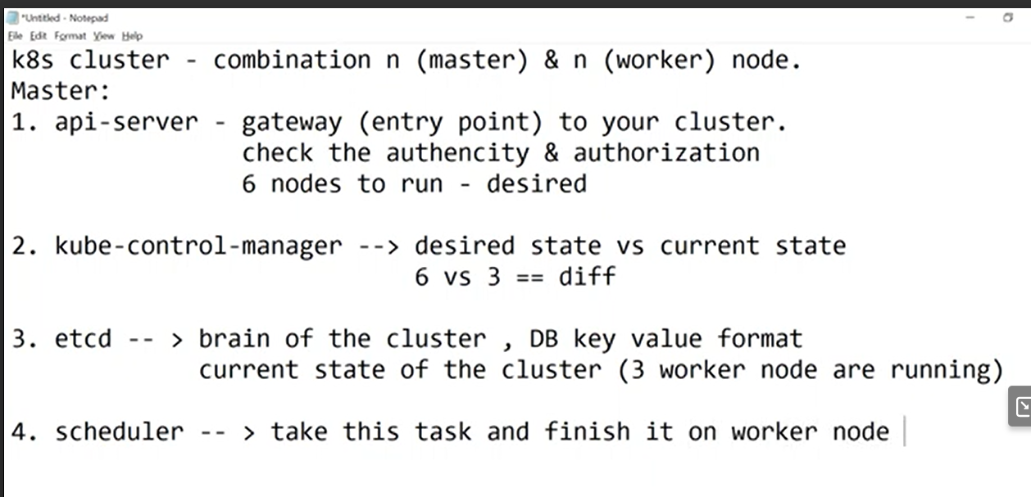

Then

**Kubelet**:

Kubelet take that task from worker node and perform the task

Kubelet inform back to my api-server that work will be complete

Agent to send and receive request from master

Then api- server go to etcd that say we have made some changes and update your database and same time it will give to end user about the update of state

like success or failed 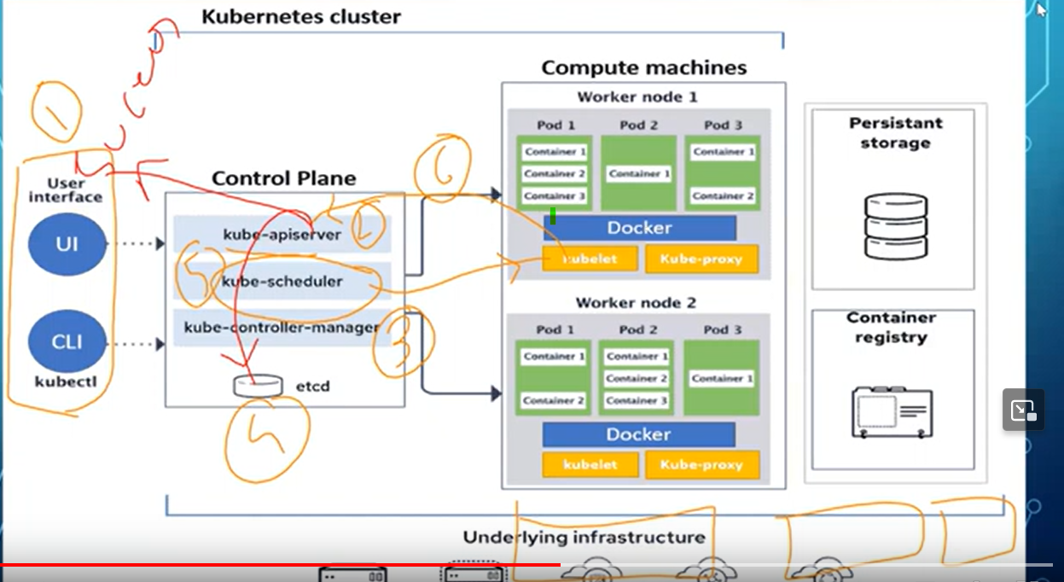

**pod** :

Kubernate by itself it not directly deal with containers

Directly kubernate does not deal with container

Pod is the smallest unit of work on K8S envirment

Pod does not restrict you that you can put anything like any container, Docker container

If you put 3 container inside pod, it will treat all 3 container as a single unit

Ideal scenario one pad there should be one container

**Kube-proxy :**

When you debug something there is a requirement that you directly want to connect to worker node

So ideal scenario this is not possible but you want to directly connect to worker node in that case you will use kube-proxy

Compute machine: worker node

KUBE-API SERVER :

FIRST AUTHENICATE THE REQUEST AND AND VALIDATES IT It then retrieves the data

from the etcd cluster and responds back

with the requested information.

kube-apiserver is the only component

that interacts directly with the etcd data store.

The other components, such as the scheduler,

kube-controller-manager and kubelet

uses the API server to perform updates

in the cluster in their respective areas.

**KUBE-SCHEDULER:**

The scheduler decides which nodes the pods are placed on depending on certain criteria

Scheduler is only responsible for deciding which pod goes on which node.

How does the scheduler assign these pods ?

The scheduler looks at each pod and tries to find the best node for it

It has set up cpu and memory requirments

The scheduler goes through two phases to identify the best node for pod

First phase : scheduler tries to filter out the nodes that do not fit the profile for ths pod

For examples : the nodes that do not have sufficient CPU and memory resources requested by the pod

2nd approce : rank nodes

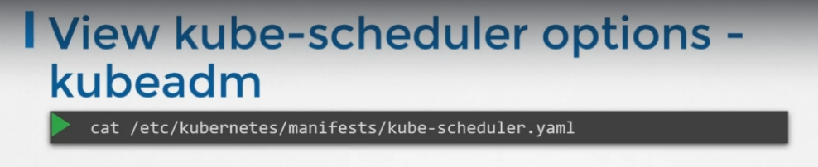

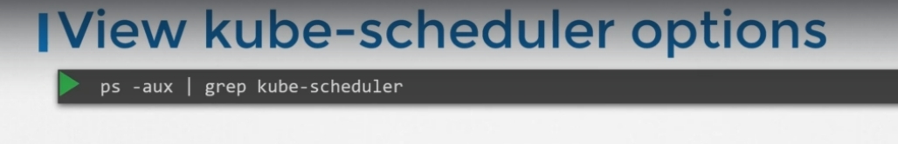

**KUBELET :**

The kubelet then continues to monitor the state of the pod and containers in it and reports to the kube API server on a timely basis.

**KUBE_PROXY:**